BABU BANARASI DAS
UNIVERSITY

2026-2027

SCHOOL OF COMPUTER APPLICATIONS
No SQL Project On
Student Management System Using MongoDB

Submitted to: Submitted by:
Mr. Harendra Singh Prashant Kumar
Department: BCA (DS & AI) Roll no: ()
Date: 30th September 1250258313

ACKNOWLEDGEMENT

I sincerely express my gratitude to my teacher Mr. Harendra Singh for giving me the opportunity to work on this NoSQL project titled “Student Management System Using MongoDB”.
This project helped me understand the basic concepts of NoSQL databases and learn how MongoDB is used to create, retrieve, update, Sorting and delete data. I also learned how different query operators such as greater than, less than, equal to, AND, and OR are used in MongoDB.
I am thankful to my teacher for the guidance and support provided throughout the completion of this project.

INTRODUCTION
MongoDB is a popular NoSQL database management system that stores data in the form of documents. Unlike traditional relational databases, MongoDB does not require data to be stored in fixed rows and columns.
In this project, a Student Management System has been created using MongoDB. The database contains information about 50 students, including their roll number, name, age, marks, and city.
Different MongoDB operations have been performed on the student data, such as inserting, displaying, updating, deleting, sorting, counting, and searching records. Comparison operators such as $eq, $gt, $lt, $gte, and $lte have also been demonstrated.

OBJECTIVES
- To understand the concept of NoSQL databases.
- To learn the basic features of MongoDB.
- To create a database and collection.
- To insert 50 student records.
- To perform CRUD operations.
- To use comparison operators.
- To perform sorting and filtering.
- To understand AND and OR operations.

1. CREATE DATABASE
MongoDB Query:
use college
Explanation: Creates or switches to the Student database.
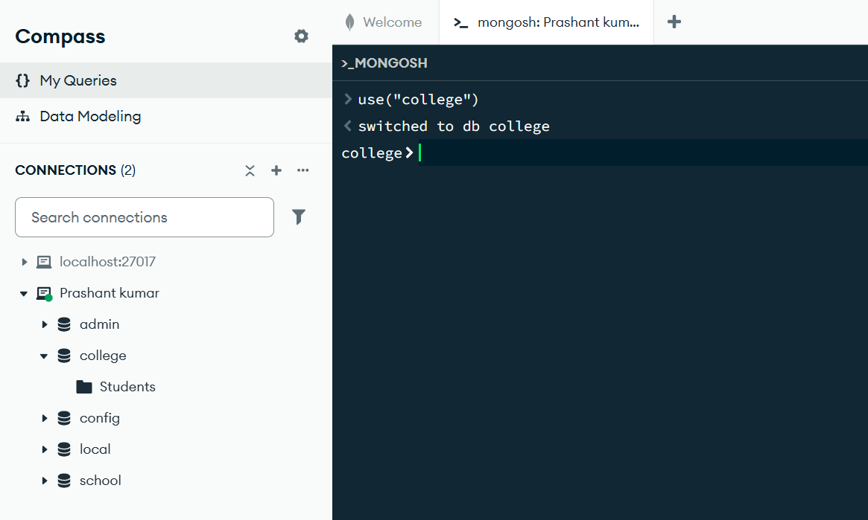
2. CREATE COLLECTION
MongoDB Query:
db. create Collection("Students")
Explanation: Creates a collection named students.
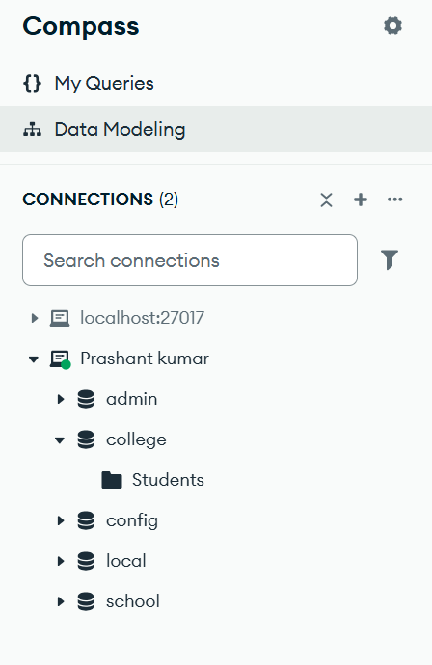
3. INSERT 50 STUDENTS
MongoDB Query:
db. students. Insert Many([ ])
{roll:1, name:"Anamika", age:19, marks:88, city:"Lucknow"},
{roll:2, name:"Uday", age:18, marks:76, city:"Jaunpur"},
{roll:3, name:"Rahul", age:20, marks:91, city:"Kanpur"},
{roll:4, name:"Priya", age:19, marks:84, city:"Varanasi"},
{roll:5, name:"Aman", age:18, marks:72, city:"Prayagraj"},
{roll:6, name:"Neha", age:20, marks:95, city:"Lucknow"},
{roll:7, name:"Rohit", age:19, marks:67, city:"Ayodhya"},
{roll:8, name:"Sneha", age:18, marks:89, city:"Kanpur"},
{roll:9, name:"Arjun", age:21, marks:78, city:"Agra"},
{roll:10, name:"Pooja", age:19, marks:93, city:"Mathura"},
{roll:11, name:"Vikas", age:20, marks:71, city:"Bareilly"},
{roll:12, name:"Kajal", age:18, marks:86, city:"Lucknow"},
{roll:13, name:"Saurabh", age:19, marks:80, city:"Gorakhpur"},
{roll:14, name:"Riya", age:20, marks:92, city:"Varanasi"},
{roll:15, name:"Aditya", age:18, marks:74, city:"Noida"},
{roll:16, name:"Simran", age:19, marks:87, city:"Ghaziabad"},
{roll:17, name:"Mohit", age:21, marks:69, city:"Meerut"},
{roll:18, name:"Anjali", age:18, marks:94, city:"Prayagraj"},
{roll:19, name:"Karan", age:20, marks:82, city:"Kanpur"},
{roll:20, name:"Nisha", age:19, marks:77, city:"Lucknow"},
{roll:21, name:"Deepak", age:18, marks:65, city:"Jaunpur"},
{roll:22, name:"Shivani", age:20, marks:90, city:"Ayodhya"},
{roll:23, name:"Varun", age:19, marks:73, city:"Agra"},
{roll:24, name:"Muskan", age:18, marks:85, city:"Mathura"},
{roll:25, name:"Abhishek", age:21, marks:79, city:"Bareilly"},
{roll:26, name:"Komal", age:19, marks:96, city:"Lucknow"},
{roll:27, name:"Nitin", age:20, marks:68, city:"Gorakhpur"},
{roll:28, name:"Shreya", age:18, marks:88, city:"Varanasi"},
{roll:29, name:"Ravi", age:19, marks:75, city:"Prayagraj"},
{roll:30, name:"Aarti", age:20, marks:91, city:"Kanpur"},
{roll:31, name:"Vivek", age:18, marks:70, city:"Noida"},
{roll:32, name:"Isha", age:19, marks:83, city:"Ghaziabad"},
{roll:33, name:"Manish", age:21, marks:64, city:"Meerut"},
{roll:34, name:"Tanya", age:18, marks:97, city:"Lucknow"},
{roll:35, name:"Sumit", age:20, marks:81, city:"Jaunpur"},
{roll:36, name:"Payal", age:19, marks:89, city:"Ayodhya"},
{roll:37, name:"Harsh", age:18, marks:76, city:"Agra"},
{roll:38, name:"Sakshi", age:20, marks:93, city:"Mathura"},
{roll:39, name:"Yash", age:19, marks:72, city:"Bareilly"},
{roll:40, name:"Divya", age:21, marks:86, city:"Lucknow"},
{roll:61, name:"Aakash", age:19, marks:58, city:"Lucknow"},
{roll:62, name:"Bhavna", age:18, marks:54, city:"Kanpur"},
{roll:63, name:"Chirag", age:20, marks:49, city:"Varanasi"},
{roll:64, name:"Diya", age:19, marks:57, city:"Prayagraj"},
{roll:65, name:"Farhan", age:21, marks:52, city:"Agra"},
{roll:66, name:"Garima", age:18, marks:45, city:"Ayodhya"},
{roll:67, name:"Hemant", age:20, marks:59, city:"Jaunpur"},
{roll:68, name:"Ishita", age:19, marks:51, city:"Lucknow"},
{roll:69, name:"Jatin", age:18, marks:47, city:"Noida"},
{roll:70, name:"Kavya", age:20, marks:56, city:"Ghaziabad"}
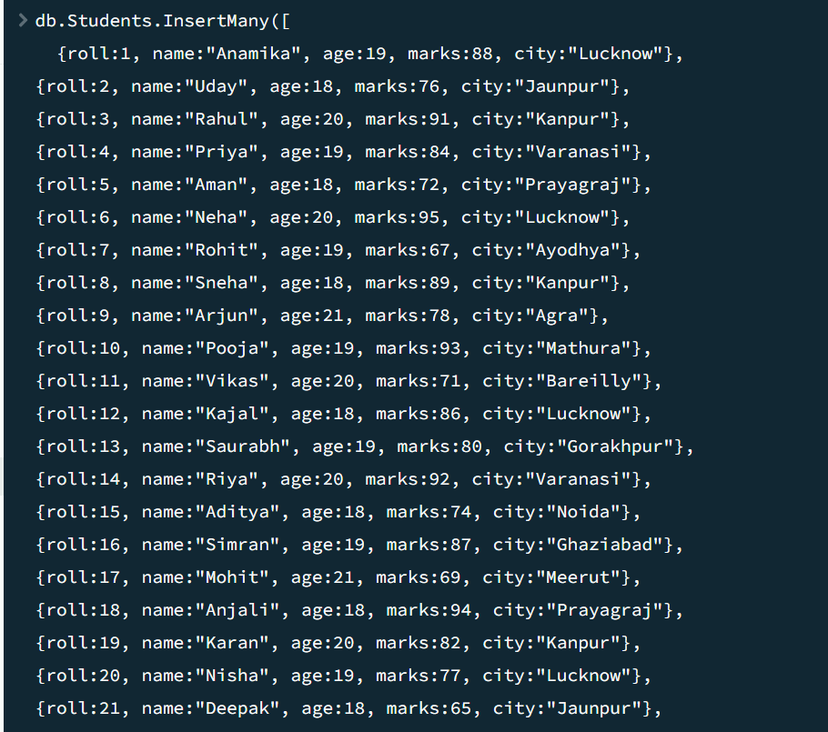

Explanation: Inserts multiple student documents into the collection.

4. DISPLAY ALL STUDENTS
MongoDB Query:
db. Students. Find ()
Explanation: Retrieves documents from the students collection.
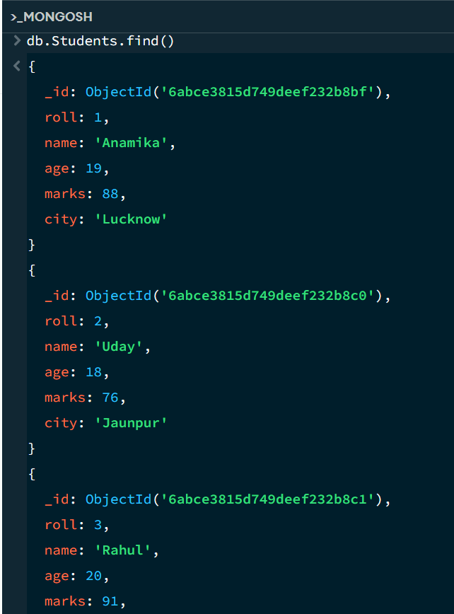

5. EQUAL TO — $eq
MongoDB Query:
db. students. Find ({marks: {$eq: 88}})
Explanation: Finds students whose marks are exactly 88.

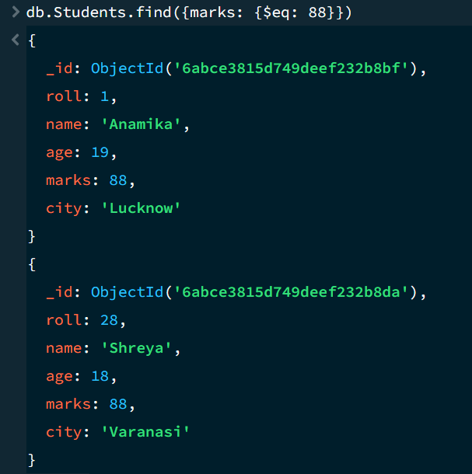
6. GREATER THAN — $gt
MongoDB Query:
db.students.find({marks: {$gt: 85}})
Explanation: Finds students whose marks are greater than 85.
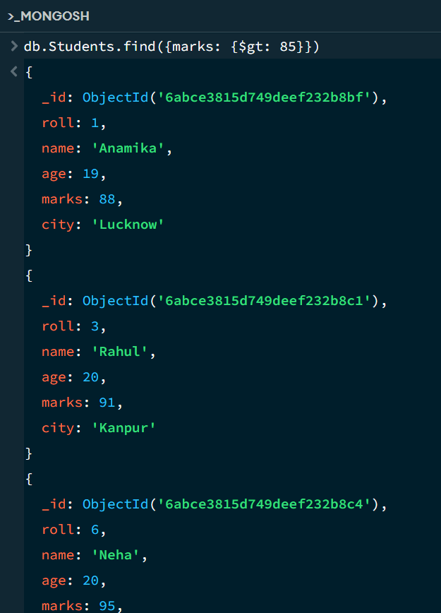

7. LESS THAN — $lt
MongoDB Query:
db. students. find ({marks: {$lt: 60}})
Explanation: Finds students whose marks are less than 60.

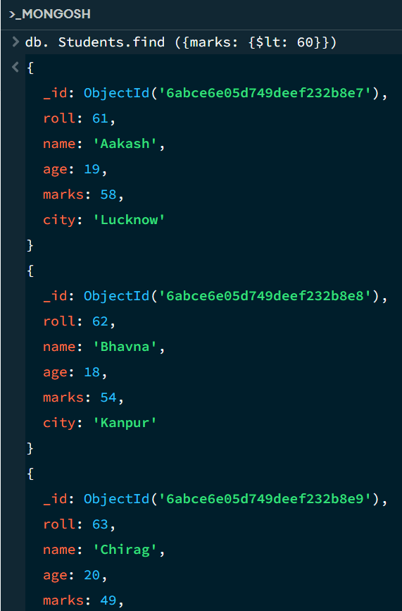
8. GREATER THAN OR EQUAL TO — $gte
MongoDB Query:
db. students. find({marks: {$gte: 90}})
Explanation: Finds students whose marks are 90 or above.

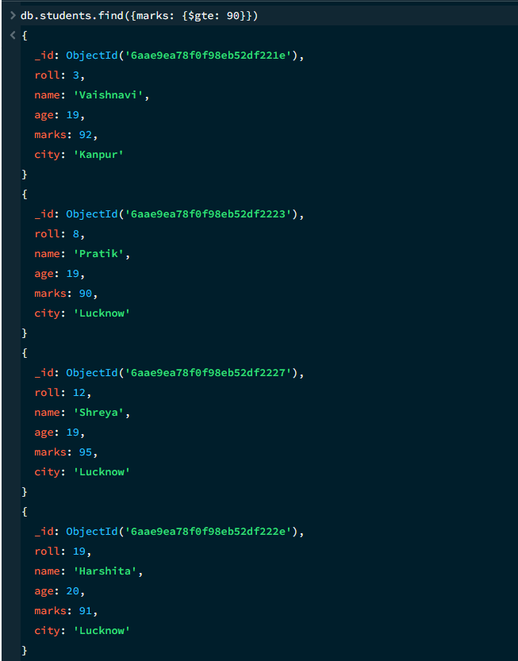

9. LESS THAN OR EQUAL TO — $lte
MongoDB Query:
db. students. find({marks: {$lte: 70}})
Explanation: Finds students whose marks are 70 or below.

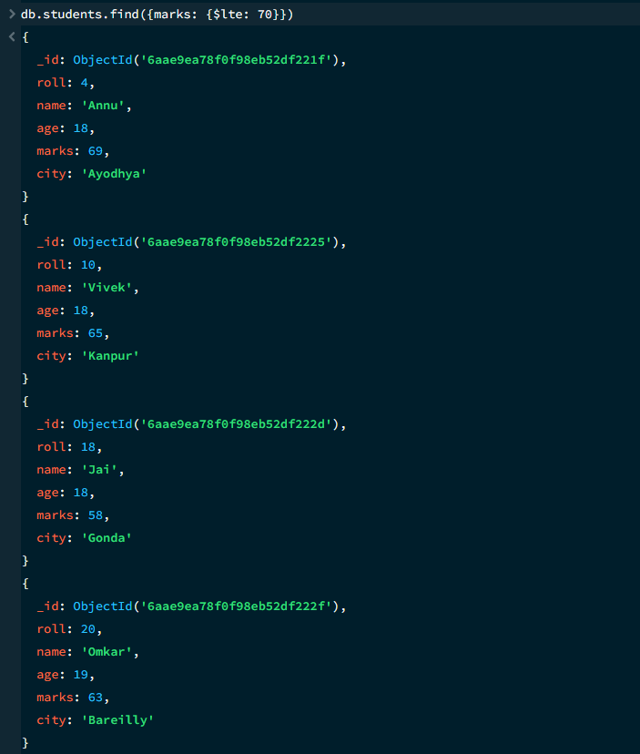

10. UPDATE OPERATION
MongoDB Query:
db.students.updateOne(
{roll:5},
{$set:{marks:95}}
)
Explanation: Updates the marks to 95 of the student with roll number 5.

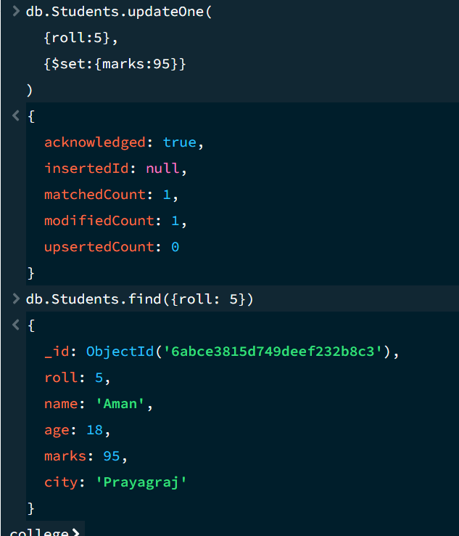

11. DELETE ONE OPERATION
MongoDB Query:
db.students.deleteOne({roll:10})
Explanation: Deletes one document matching roll number 10.

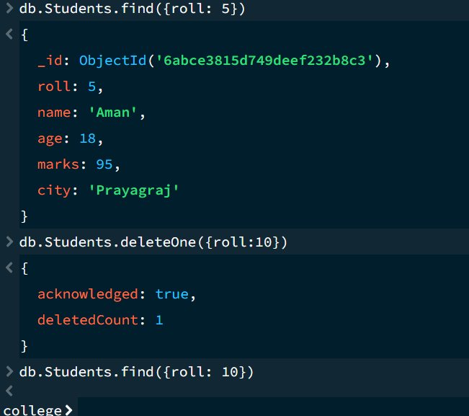

12. DELETE MANY OPERATION
MongoDB Query:
db.students.deleteMany({
marks: {$lt:60}
})
Explanation: Deletes all students having marks below 60.

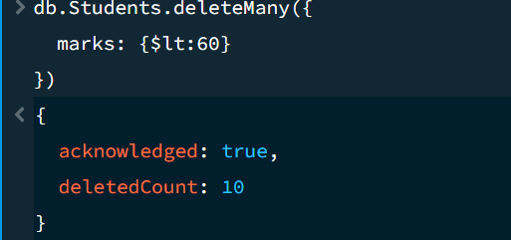
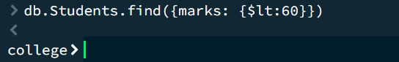
13. AND OPERATION — $and
MongoDB Query:
db. students. find({
$and:[
{marks:{$gt:80}},
{age:19}
]
})
Explanation: Finds students satisfying both conditions.
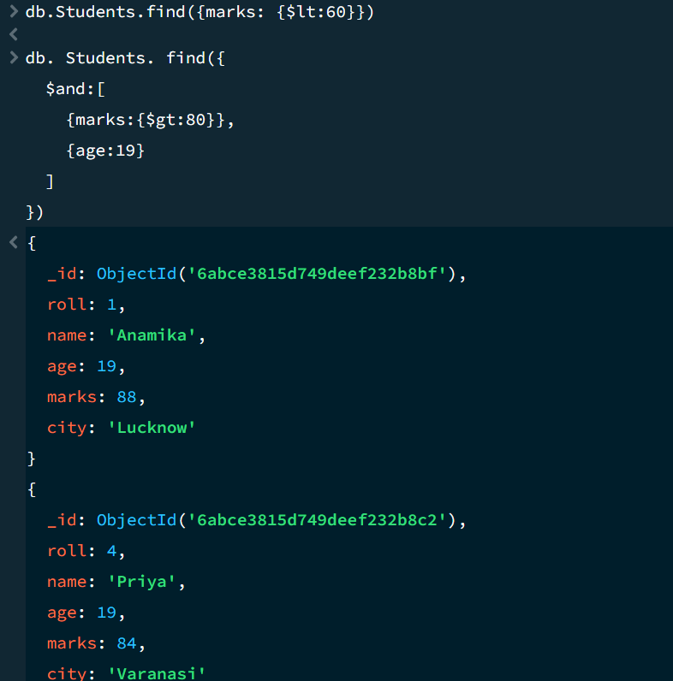

14. OR OPERATION — $or
MongoDB Query:
db.students.find({
$or:[
{city:"Lucknow"},
{city:"Kanpur"}
]
})
Explanation: Finds students from Lucknow or Kanpur.
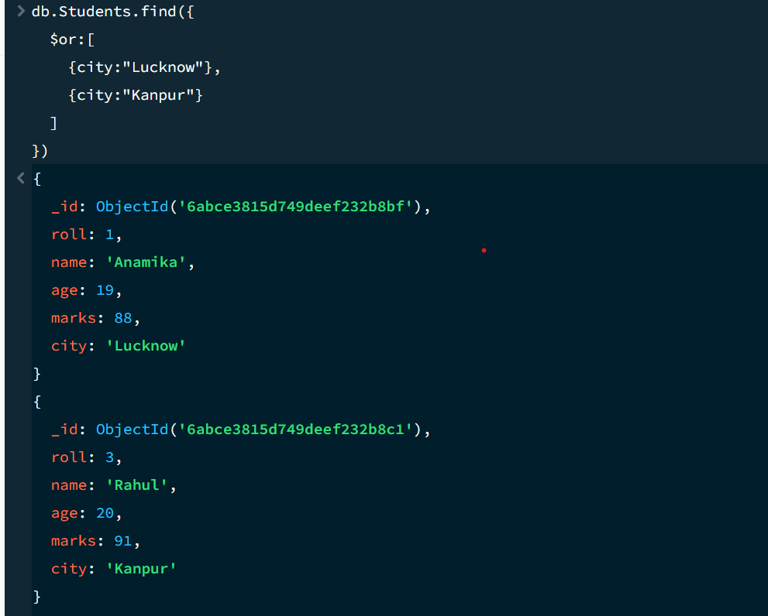

15. SORT OPERATION
A.MongoDB Query:
db. students. find (). sort({marks : 1})
Explanation: Sorts students by marks from lowest to highest. Use 1 for ascending order.
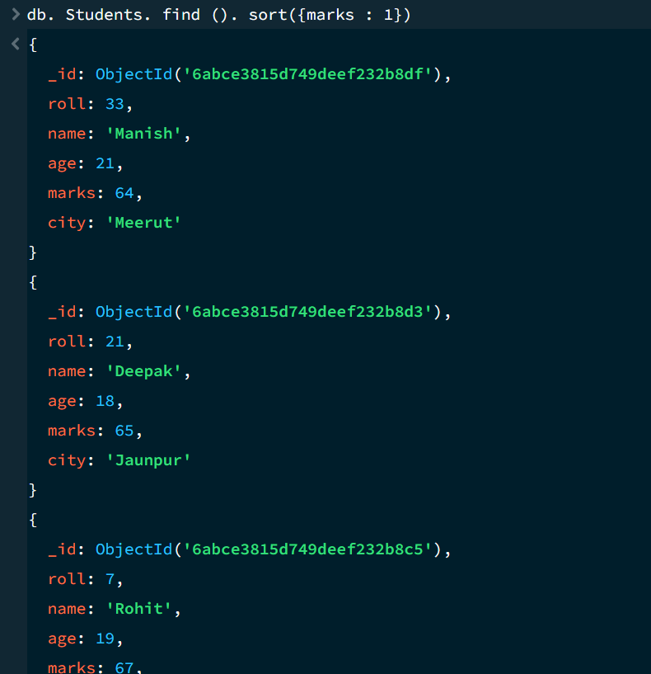

B. MongoDB Query:
db. students. find (). Sort ({marks: -1})
Explanation: Sorts students by marks from highest to lowest. Use -1 for descending order.
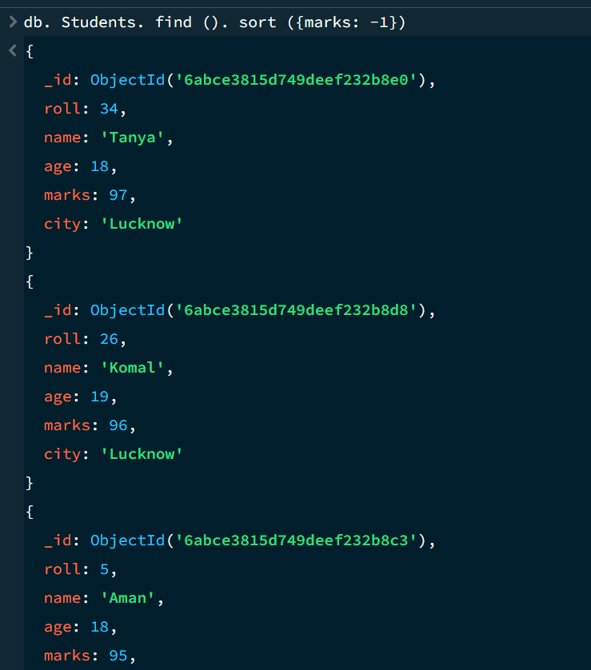
16. LIMIT OPERATION
MongoDB Query:
db. students. find (). limit (5)
Explanation: Displays only the first five documents.

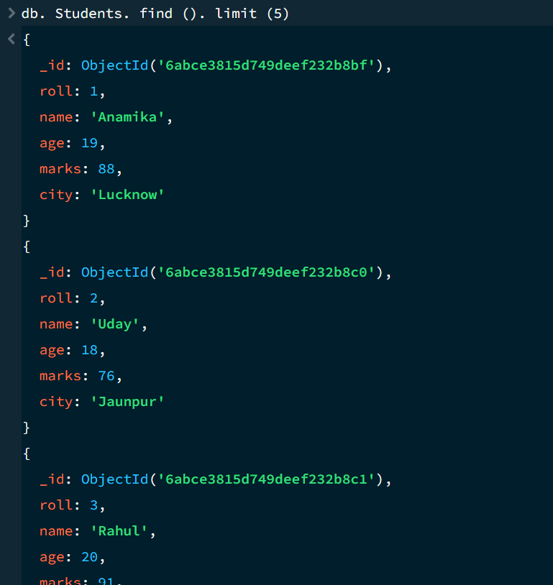

17. SEARCH BY CITY
MongoDB Query:
db.students.find({city:"Lucknow"})
Explanation: Finds all students whose city is Lucknow.
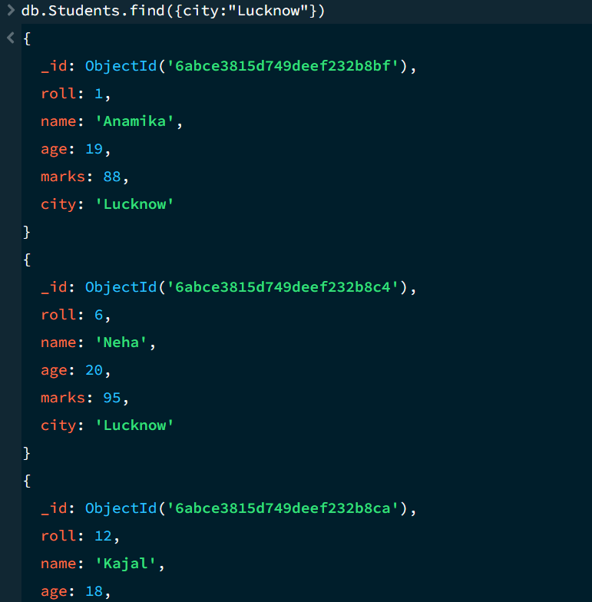

18. COUNT DOCUMENTS
MongoDB Query:
db. students. count Documents ()
Explanation: Counts documents currently present in the collection (performing after the delete function).
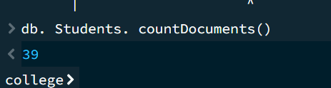

MONGODB OPERATORS USED:

Operator | Meaning | Example
$eq | Equal to | marks: {$eq:88}
$gt | Greater than | marks: {$gt:85}
$lt | Less than | marks: {$lt:60}
$gte | Greater than or equal to | marks: {$gte:90}
$lte | Less than or equal to | marks: {$lte:70}
$and | All conditions true | $and:[...]
$or | At least one condition true | $or:[...]

CONCLUSION
This project provided practical knowledge of NoSQL databases using MongoDB. A Student Management System containing student information was created and different MongoDB operations were performed on the data.
Through this project, I learned how to insert, retrieve, update, and delete documents. I also learned how to Ascending order & descending order data, comparison operators such as $eq, $gt, $lt, $gte, and $lte work, along with logical operators such as $and and $or.
Overall, this project helped me understand how MongoDB can be used to manage and query student data efficiently.

